OPEN CALL: ARTIST / ILLUSTRATOR / GRAPHIC DESIGNER
Ealing’s Screen Industries Revealed

Application deadline: Friday 23 January 2026
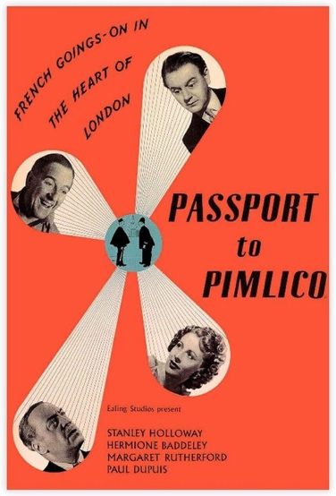
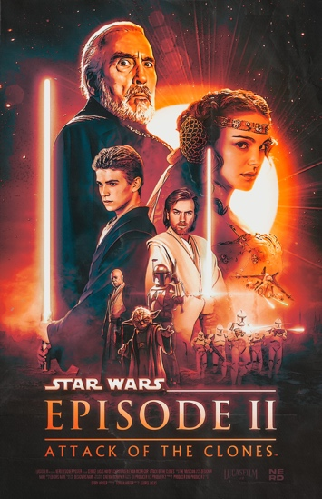
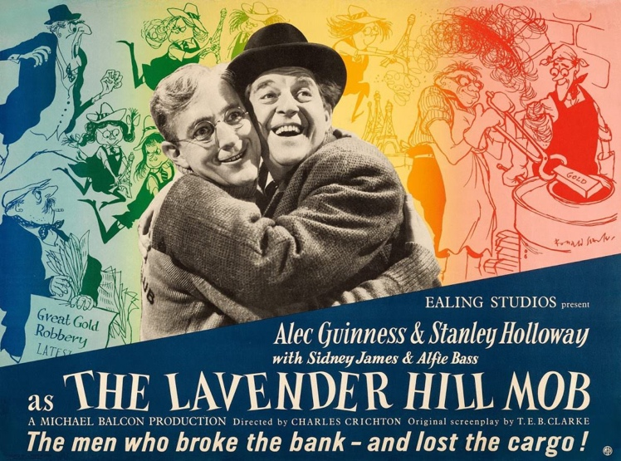

Poster designs: Passport to Pimlico, The Lavender Hill Mob, Star Wars Episode II, Attack of the Clones.

Ealing Council and Loom Projects are seeking to commission an artist, illustrator or graphic designer to create a series of original artworks celebrating the borough’s film and TV industries inspired by iconic film posters. The commissioned images will be displayed across the borough and used to promote Ealing’s Screen Industry Cluster, supporting the Council’s commitment to cultural placemaking, the creative economy, and the celebration of local identity.

This commission offers an opportunity to reinterpret the visual language of cinema and TV, in a way that is bold, playful and accessible, creates a cohesive visual identity that can be experienced by residents, workers and visitors across Ealing and shines a light on the hidden stories and talents that make up Ealing's thriving and diverse Screen Industry.
The commissioning programme is being led by Loom Projects, an arts and culture consultancy based in Park Royal with extensive experience delivering public art projects and supporting local creative communities.
Context: Ealing’s Film Heritage

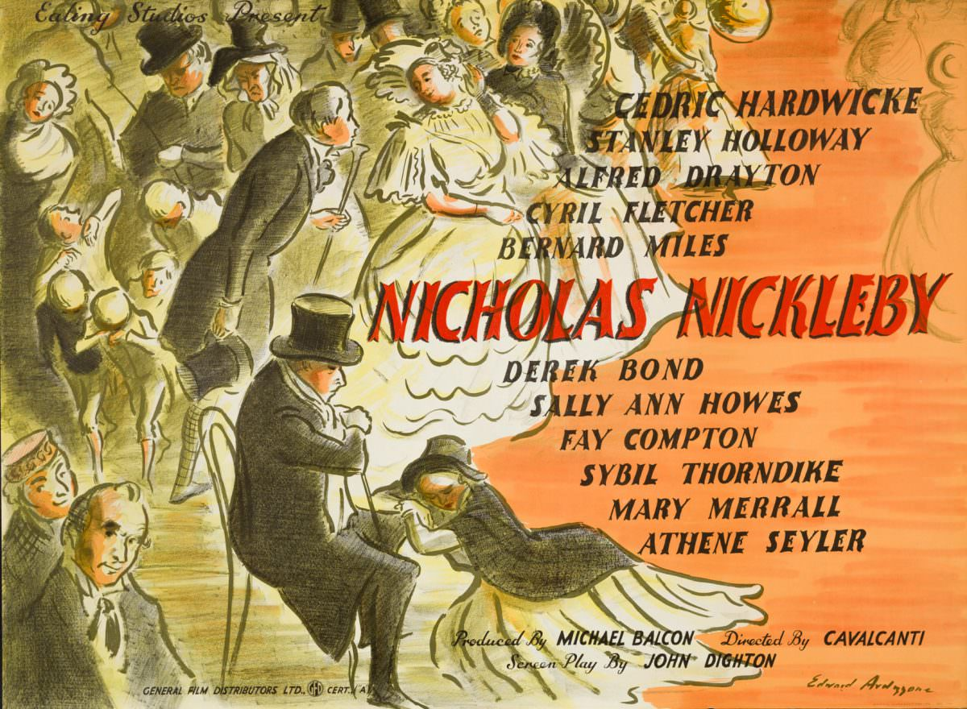
Poster design for 1947 Ealing Studios film Nicholas Nickleby, an adaptation of the Charles Dickens novel by artist Edward Ardizzone

Ealing has a long and internationally recognised relationship with the film and TV industry. It is home to Ealing Studios - the world’s oldest continuously working film studio and synonymous with the post-war “Ealing Comedies” that helped shape British cinema.

Today, Ealing continues to play an active role in the contemporary screen sector, supporting production, post-production, education and creative talent across film, television and digital media. Major film and TV shows made locally in recent years range from Notting Hill to Star Wars 2: Attack of the Clones to Downton Abbey and The Crown. The West London Film cluster employs 43,000+ workers, accounting for over a third of London’s (and one fifth of the UK’s) workforce in the TV and Film industry. The Acton and Park Royal Creative Enterprise Zone (CEZ), jointly delivered with OPDC, supports 4,500+ jobs, making it London’s densest area for screen and digital employment. Iconic moving image equipment brand Panavision has its UK base in Greenford, while Farley's in east Acton have been hiring props to film and TV productions since 1962.

Whilst the industry has faced considerable challenges since the disruption of Covid-19, production within Ealing remain strong due to the borough's combination of heritage studios, extensive supply chains and excellent connectivity. Ealing Studios reopened in 2025 following a £20M revamp, including new state of art office facilities. Park Royal is home to multiple busy operating studios – including Garden Studios, Versa Studios and Klatch Studios – as well as many prop houses, set builders such as DRS, lighting and equipment hire, and circular economy initiatives reusing waste material from film sets like Re-Collective.

This project responds directly to these challenges and opportunities. By strengthening the visibility and identity of the sector, the programme aims to:

- support recovery and growth, including driving up occupancy
- support local job creation across the supply chain, including creating opportunities for young local talent
- reinforce Ealing's position both nationally and internationally as a centre for film, TV and other screen-based production

The Commission

The Screen Industry Cluster brings together studios, businesses, training providers and creatives across the borough. Whilst the heritage of Ealing Studios is well known, this project aims to celebrate and promote the current screen industry in the borough today. This commission will also build upon The West London Screen Industries Revealed, an ongoing research programme delivered by the University of West London (UWL) which is due to report in early 2026.

We are keen to highlight the full range of companies within the cluster and their roles in film production – from the studios to the riggers, prop houses and lighting techs. By celebrating the full supply chain that make these productions possible, the project will make these “invisible” parts of the industry visible whilst demonstrating why Ealing continues to be a prime production location within the UK’s screen industry.

The appointed artist will be commissioned to develop a series of artworks (minimum 6 - final number TBC) inspired by the graphic language, composition and storytelling of iconic film posters.

The artworks should draw inspiration from the visual language of classic and contemporary film posters while remaining original works rather than reproductions or direct pastiches. The artworks should each be distinct from one another whilst having a clear visual and narrative link across the entire series.

This series of artworks will be displayed across the borough, as part of a campaign to launch and celebrate a new name and identity for Ealing's screen industry cluster, which is in development alongside the commission.

This artwork commission aims to:
- Celebrate and promote Ealing’s screen industries to residents and visitors
- Increase visibility of the diversity and scale of the Screen Industry Cluster
- Showcase and celebrate “the talent behind the talent”
- Create striking, high-quality visuals for use in public space

The artworks will:
- Be displayed across multiple locations within the borough
- Need to be adaptable for different formats and scales
- Function as a ecognizable series with a consistent visual identity
- Contribute positively to the character and animation of public space
Further details on locations, formats and reproduction methods will be provided to the selected artist upon appointment.

Who We’re Looking For:

This opportunity is open to:
- Artists
- Illustrators
- Graphic designers / Designers working across print and image-based media

Applicants should demonstrate:
- A strong visual voice and understanding of composition and typography
- An interest in film, storytelling, or visual culture
- An ability to develop ideas that resonate with diverse audiences
- Work that can be reproduced successfully at varying scales
Desirable but not essential:
- Experience producing work for public display or promotional campaigns is desirable but not essential.
- Knowledge and interest in Ealing’s screen and creative industries

Artist Fee

The artist fee will be £12,000* with the possibility for increased scope should the number of artworks increase.

The fee will include:
- Research and Concept development
- Design of the artwork series (minimum 6 designs)
- Delivery of final digital files for reproduction in various formats (eg: a portrait/landscape version of each)
- Involvement in any associated PR or marketing opportunities (to be discussed)

Production, printing and installation costs will be managed separately.

*Ex VAT

What to Submit

This is an expression of interest. Applicants are not required to submit finished designs.
Submissions should include:
- A brief explanation of your interest in the brief, including any previous experience with film, poster design or visual storytelling (max 250 words)
- A short statement outlining your creative approach to the brief (max 250 words)
- Examples of relevant previous work (up to 5 images or links)
- Confirmation that you would be able to begin work immediately upon appointment - delivery deadlines are tight for completion of this project.
Submissions will be assessed on:
- Strength and clarity of creative approach
- Relevance to Ealing’s screen heritage and cultural context
- Quality and originality of previous work
- Ability to deliver a coherent series suitable for public display

Diversity, Inclusion & Accessibility

Ealing Council is committed to equality, diversity and inclusion across its cultural programmes. Artists from underrepresented backgrounds are strongly encouraged to apply. `

The Council will seek to ensure that access needs are supported throughout the application and commissioning process and that the resulting artworks contribute to a welcoming and inclusive public realm. To discuss your access needs, including alternative formats for submitting your application, please contact us via email: opencall@loomprojects.co.uk

How to Apply

Please email your submission to: opencall@loomprojects.co.uk by 12 noon on Friday 23 January 2026.

If you have any access requirements clarification questions about the application process, please email Grace Williams on the above email address by Monday 19 January 2026.

Timeline

Open call issued: Monday 12 January 2026
Submission deadline: Friday 23 January 2026, 12 noon
Interviews w/c: 26 January 2026
Artist appointed w/c: 2 February 2026
Artwork development: 2 February - mid March 2026
Completion: mid March 2026 (date TBC)

About Loom
Loom is a west London based arts and culture consultancy that brings ambitious artist-led projects to life by connecting people, partners, and places. They help organisations and businesses to commission art and cultural programmes, often rooted in a particular place. W: www.loomprojects.co.uk E: hello@loomprojects.co.uk

About UKSPF
Funding for this commission is derived from the Government UK Shared Prosperity Fund (UKSPF). The fund aims to improve pride in place, while increasing life chances, investing in communities, and supporting local business, people and skills.
Other Ealing Culture projects delivered with UKSPF funding include:
Poetry High Streets: Ealing Culture has been working with poets, creatives, local businesses and the people of the borough to engage in conversations, provide creative workshops and engage with the local community to uncover the stories and voices on our high streets. This has resulted in a series of six public installations across Hanwell, Pitzhanger Lane and Oldfields Circus, featuring new poetry by Laurie Bolger, Mr Gee and Shagufta Iqbal.

Destination Southall Public Art Project: Southall will be bursting with colour and creativity this year, with seven artists working across 6 locations that will be transformed with murals, striking sculptures and imaginative public art. New works by artists including Prem Sahib and JG Contemporary Art were selected by a panel made up council representatives and members of community groups including Southall Community Alliance, Southall Black Sisters, Southall Young Adult Centre, Open Southall and Pitzhanger Manor and Gallery.

Other Precedent Projects for Inspiration
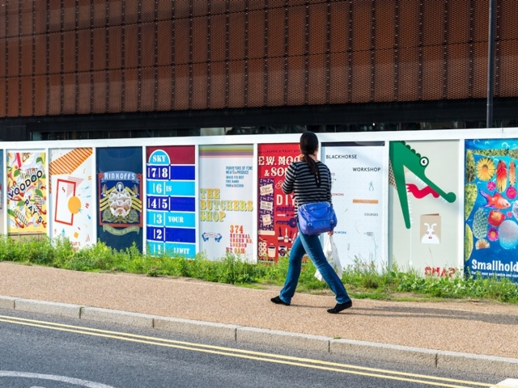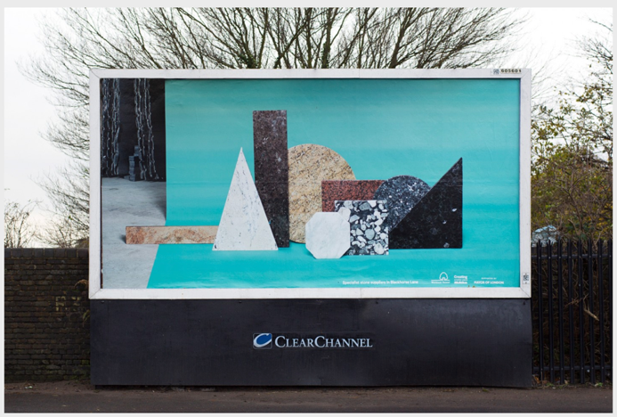

Your Ad Here by Create London (left)
Blackhorse Lane Billboards by Europa (right)

History of Ealing's Film Posters

BFI website, Ealing and the art of the film poster, Claire Smith, December 2012

Vintage Showbiz website, Ealing Studios: A Visual History of the Movie Posters of the 1940s and 1950s, Gabriel Thomas

